CIS40A Lab 9: Installing DNS, Setup DNS records, Active Directory and Dynamic Updates in DHCP using Windows Server 2022.
In this lab, we will use Windows Server 2022 virtual machine to configure DNS, DNSSEC and setup Dynamic Updates in DHCP. You can download server VM and extract the folder once downloaded. See below lab procedures and complete the required tasks.
Server 2022 VM Download:

Part A: Installing DNS
- Use the above link to download the zipped folder that contains CIS40A Server.
- Once the zipped folder is downloaded, right-click the CIS40A Server.zip folder and select Extract All.
- Open VirtualBox app and click Tools, then click +, then locate the extracted folder from Downloads, open its sub-folders CIS40A Server à Server22VM à Server22, then select Server22.vbox and click Open.
- In VirtualBox Manager, click Settings (orange gear), then click Network.
- On the drop-down menu, click Internal Network and click OK.
- In Settings, click System on the left.
- Change Base Memory to 8000 MB
- Click Process tab, change the value for processors to 4. Click OK.
- Click à Start button to launch VM.
- On VirtualBox app, click Input menu at the top and select Insert Ctrl+Alt+Del
- Login Windows Server 2022, password: CIS40A!
- On Server Manager, click Local Server tab, then click IPv4 address next to Ethernet.
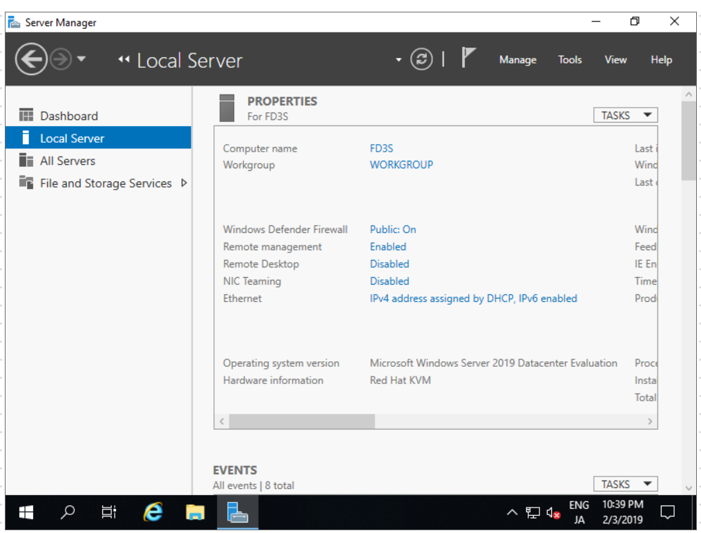
- Right-click Ethernet icon and open Properties.
- Select Internet Protocol Version 4 and click Properties button.
- Click Use the following IP address. Input the address below and change x to a value between 50-100
IP Address: 172.16.0.x
Subnet mask: 255.255.0.0
Default gateway: 172.16.0.1

- Click Use the following DNS server addresses, then enter the IP address (172.16.0.x) from the previous step.
- Click OK to close the IP address properties window. Close the Ethernet Properties and Network Connections windows.
- Restart the VM by clicking on the Windows button and select Restart.
- Click on Dashboard on the left. In Server Manager, click Add Roles and Features
- Keep Role-based in feature-based installation option selected. Click Next button at the Server Selection.
- Click DNS Server from the Roles list.
- Click Add Features to add management tools, remote and role administration tools.
- Click Next button to proceed with DNS role installation.
- Click Next button to proceed with selected features.
- Review information about DNS server and Things to Note.
- What type of services should be integrated with DNS server? Active Directory Domain Services

- Can you install DNS while installing Active Directory Domain Services? No, DNS should be installed first. If you’re installing a domain controller, then you can install ADDS at the same time

- Click Next to proceed.
- Click Install button and wait for the installation. This process will take about 5 minutes.
- Once the installation is completed, click the Close button.
- Click on Tools, then click DNS to open the DNS Manager console.
- Right-click the server (WIN-...) on the left and choose New Zone.
- Click Next to proceed with New Zone Wizard.
- Keep Primary Zone selection and click Next.
- Keep Forward Lookup Zone option and click Next.
- Enter the Zone name: YourFullName.com then click Next.
- Click Next to proceed with the new zone file.
- Keep Do Not Allow Dynamic Updates option and click Next.
- Click Finish button.

Part B Install Active Directory Services
- Return to Server Manager by clicking Server Manager at the top.
- Click Add Roles and Features
- Click Next to proceed
- Keep Role-based or feature based option selected, click Next.
- Keep the server selection, click Next.
- Select Active Directory Domain Services and DHCP then click Add Features button to add correlated AD and DHCP features. Then click Next.
- Click Next to proceed with default selection of Features.
- Review the information about ADS and answer the following questions:
- What does Active Directory Services store? Information about users, computers, and other devices on the network
- How many domain controllers are recommended in a domain? 2 Why? Redundancy

- Click Next to proceed.
- Click Install and wait for the installation to complete, then click Close.
- At the top, locate the flag icon and click on the Warning notification (yellow exclamation) to begin post deployment configuration. Select Post-Deployment Configuration for Active Directory.
- Click Promote This Server to a Domain Controller link (blue link in the Post-deployment Configuration option)
- Click Add a New Forest and Enter the Root Domain Name: YourFullName.com, then click Next. Note: Input your full name in the domain name.
- Keep default selection on Domain Controller options and click Next.
- Keep the option Windows Server 2016 functional level and domain functional level.
- Enter the password for Restore Mode: CIS40A!
- Click Next.
- Click Next at DNS Delegation.
- Enter NetBIOS Name: YourFullName, then click Next.
- Take a screen capture of the Paths, then click Next.
- Review selections then click Next.
- Click Install and wait for the installation to complete.
- Return to the Server manager and take a screen capture of the installed server roles, DNS and ADS.

Part C: DNSSEC and Zones
- Click on Tools and select DNS
- In DNS Manager, click on Forward Lookup Zone (this was established from the prior lab).
- Right-click the zone that is named YOURFULLNAME.com and select DNSSEC, then click Sign the Zone.
- Click Next to proceed in the setup wizard.
- Select Use Default Settings to sign zone option, then click Next.
- Click Next to proceed in creating the security extension for DNS.
- Click Finish.
- Right click Reverse Lookup zone and select New Zone.
- Verify Primary Zone is selected, then click Next
- Select the first option, To All the Servers running on Domain Controllers In this Forest, then click Next.
- Keep the first option, IPv4 Reverse Lookup Zone. Click Next.
- Enter the IP network ID, then click Next.
- Keep the first option selected, then click Next.
- Click Next, then click Finish.
- Double click the newly created zone under Reverse Lookup Zones.
- How many records do you find? 2
- What are the records? A Start of Authority record and a Name Server Record
- Use Unit 9 notes, textbook, or the DNS manager to find information about these records. Briefly describe the functionality of these records. SOA stores the settings for the DNS zone, as well as the increment number. The NS Record specifies the authoritative DNS server, and it’s IP address.

- Take a screen capture for lab submission.

- Double-click one of the records and view the properties.
- What is set for the default minimum TTL? 1 hour

- Click on the General Tab and view the record properties.
- Is the record Active Directory integrated? yes
- What is the setting for this record’s Dynamic Updates? Secure Only

- Click on Aging button, then select Scavenge stale resource records, then click OK.
- Click OK button to close the record property sheet.
- Close DNS Manager.

Part D: Configure Dynamic Updates for DNS in DHCP server
- Click on Tools and open DHCP Manager.
- In DHCP Management console, click the server and right click IPv4, then select Properties.
- Click Automatically Update Statistics and set the value to 60 minutes or 1 hour 0 minutes. Then click Apply.
- Click on DNS tab and view the settings.
- When are DNS records dynamically updated? Only if Requested By DHCP Clients
- What happens to the PTR records when the lease is ended? They are Discarded
- Click on Advanced tab.
- Where can you find the audit file log for DHCP? C:\Windows\system32\dchp
- Click OK to close the property sheet.
- Close the DHCP Manager.
- Shutdown Windows Server VM.
- Login Canvas and submit a document that contains screen capture, lab questions and answers.
- Eject and remove USB drive.
- Shutdown the computer.

